Bahria University,

Karachi Campus



LAB EXPERIMENT NO.

11

LIST OF TASKS

|  |  |
| --- | --- |
| TASK NO | OBJECTIVE |
| 01 | Simplify the following equations using Boolean Laws & Construct Truth tables  1. F = (A+ B). (A+ C)  2. F = A.B + B.C. (B + C)  3. (𝐴̅)(𝐴 + 𝐵) + (𝐵 + 𝐴)(𝐴 + (𝐵̅) |
| 02 | Simplify the following equation using Boolean Laws. Construct the Truth Tables to verify that the simplified equation gives the same result as that of the original equation.  𝐹 = (𝐴 + 𝐶)(𝐴𝐷 + 𝐴 𝐷) + A ̅𝐶 + C |

Submitted On:

____________

(Date: DD/MM/YY)

**Task No. 1: Simplify the following equations using Boolean Laws & Construct Truth tables**

1. **F = (A+ B). (A+ C)**

**Solution:**

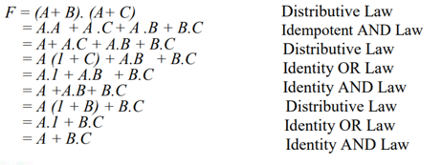

|  |  |  |  |
| --- | --- | --- | --- |
| **A** | **B** | **C** | **(A . B) + (A . C)** |
| 1 | 1 | 1 | 1 |
| 0 | 1 | 1 | 1 |
| 1 | 0 | 1 | 1 |
| 0 | 0 | 1 | 0 |
| 1 | 1 | 0 | 1 |
| 0 | 1 | 0 | 0 |
| 1 | 0 | 0 | 1 |
| 0 | 0 | 0 | 0 |

1. **F = A.B + B.C. (B + C)**

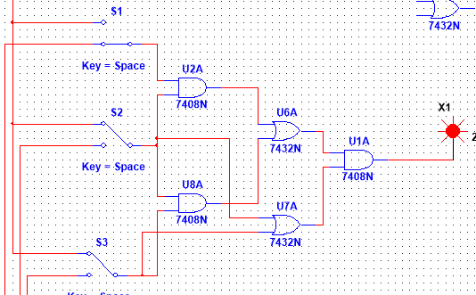

|  |  |  |  |
| --- | --- | --- | --- |
| **A** | **B** | **C** | **A.B + BC(B + C)** |
| 1 | 1 | 1 | 1 |
| 0 | 1 | 1 | 1 |
| 1 | 0 | 1 | 0 |
| 0 | 0 | 1 | 0 |
| 1 | 1 | 0 | 1 |
| 0 | 1 | 0 | 0 |
| 1 | 0 | 0 | 0 |
| 0 | 0 | 0 | 0 |

1. **(𝐴̅)(𝐴 + 𝐵) + (𝐵 + 𝐴)(𝐴 + (𝐵̅)**

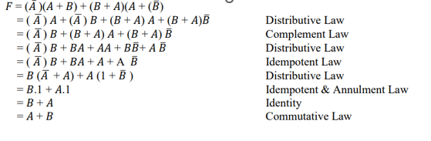

|  |  |  |
| --- | --- | --- |
| **A** | **B** | **(!A)&(A | B) | (B | A)&(A | !B)** |
| 1 | 1 | 1 |
| 0 | 1 | 1 |
| 1 | 0 | 1 |
| 0 | 0 | 0 |

**Task 1**

**𝐹 = (𝐴 + 𝐶)(𝐴𝐷 + 𝐴 𝐷) + 𝐶 + *C***

(A + C) (AD + AD) + $\overline{A}$ C

(A + C) (AD) + C Idempotent & Annulment Law

A.A.D + A.C.D + C Distributive Law

A.D + C (A.D + 1) Distributive Law

**A.D + C** Annulment Law

|  |  |  |  |  |
| --- | --- | --- | --- | --- |
| **A** | **B** | **C** | **D** | **(A+B)((AD) +(AD)) +A’C+ C** |
| 1 | 1 | 1 | 1 | 1 |
| 0 | 1 | 1 | 1 | 0 |
| 1 | 0 | 1 | 1 | 1 |
| 0 | 0 | 1 | 1 | 0 |
| 1 | 1 | 1 | 0 | 0 |
| 0 | 1 | 1 | 0 | 0 |
| 1 | 0 | 1 | 0 | 0 |
| 0 | 0 | 1 | 0 | 0 |
| 1 | 1 | 0 | 1 | 1 |
| 0 | 1 | 0 | 1 | 1 |
| 1 | 0 | 0 | 1 | 1 |
| 0 | 0 | 0 | 1 | 1 |
| 1 | 1 | 0 | 0 | 1 |
| 0 | 1 | 0 | 0 | 1 |
| 1 | 0 | 0 | 0 | 1 |
| 0 | 0 | 0 | 0 | 1 |

|  |  |  |  |
| --- | --- | --- | --- |
| **A** | **D** | **C** | **AD+ C** |
| 1 | 1 | 1 | 1 |
| 0 | 1 | 1 | 1 |
| 1 | 0 | 1 | 1 |
| 0 | 0 | 1 | 1 |
| 1 | 1 | 0 | 1 |
| 0 | 1 | 0 | 0 |
| 1 | 0 | 0 | 0 |
| 0 | 0 | 0 | 0 |